Dexmedetomidine in OB Anesthesia

Michael Douglas, MD; Leonard Soloniuk, MD
Riverside University Health System
Last Updated 26 October 2023

Dexmedetomidine
- History
  - First FDA approved in 1999 as a short-term sedative and analgesic (<24 hours) for critically ill or injured people on mechanical ventilation in the intensive care unit (ICU).
  - Not FDA approved for routes other than IV
  - Not FDA approved for OB use

- Mechanism of action
  - No small molecule drug interacts with only 1 protein

  - Alpha-2 agonist and other sites of action (HCN channel blockade)
  - HCN channel blocker
    - HCN = hyperpolarization-activated cyclonucleotide-gated cation channel
  - Pain modulation: Alpha-2 in substantia gelatinosa¹ in the dorsal horn of the spinal cord which Inhibits release of substance P and glutamate, key neurotransmitters for pain, at the dorsal horn of the spinal cord.
  - Local anesthetic potentiation: Potentiation of local anesthetics by increasing cellular hyperpolarization² and HCN channel blockade
  - Vasoconstriction: Alpha-1 agonist potentially causing some vasoconstriction³ which may delay uptake of local anesthetic from the injection site.
  - Sedation: Dexmedetomidine induces sedation by activating alpha-2 adrenergic receptors in the locus coeruleus, which is the primary site of noradrenergic neurons in the brain.

- Use in non-OB anesthesia
  - sedation, anxiolysis, sympatholysis, analgesia, cardiovascular stability on induction, minimal effect on respiratory function for awake intubation or MAC

- Relation to clonidine; epidural and spinal clonidine
  - Clonidine is closely related to dexmedetomidine as they are both alpha-2 adrenergic agonists. Clonidine has been used as an adjunct in neuraxial anesthesia (epidurals and spinals) for many years to prolong analgesia. Some key points about clonidine:
    - Clonidine activates alpha-2 receptors in the spinal cord which inhibits pain signaling. This produces analgesia and extends the duration of neuraxial blocks.
    - Typical dose of clonidine added to epidural infusions is 1-2 mcg/mL. For single shot spinals, doses of 15-30 mcg are often added to local anesthetics.
    - Clonidine is FDA approved for epidural use (Duraclon®); there is extensive literature supporting its use.
    - Intrathecal clonidine has considerable experience (e.g. Polyanalgesic Consensus Conference for intrathecal pumps)
    - Dexmedetomidine is a newer and more selective alpha-2 agonist
      - More selective: ɑ2:ɑ1 ratio 8-10 x more selective for dexmedetomidine
      - It provides similar analgesia and potentially has a better side effect profile. There is active research on its neuraxial use.

- Safety in pregnancy⁴
  - Category C due to potential harm in animal studies.
  - In vitro study demonstrated that dexmedetomidine has the potential to enhance the frequency of uterine contractions
  - High placental transfer but remains in the placenta; little to no detectable fetal serum levels
  - Studied at IV infusion and bolus induction doses with no change in fetal HR, BP, APGAR 1 and 5 min
  - No neurotoxicity; possibly protective against local anesthetic neurotoxicity⁵

References:
- Ishii H, Kohno T, Yamakura T, Ikoma M, Baba H. Action of dexmedetomidine on the substantia gelatinosa neurons of the rat spinal cord. Eur J Neurosci. 2008 Jun;27(12):3182-90. doi: 10.1111/j.1460-9568.2008.06260.x. Epub 2008 Jun 1. PMID: 18554299; PMCID: PMC2658019.
- Bao, N., Shi, K., Wu, Y. et al. Dexmedetomidine prolongs the duration of local anesthetics when used as an adjuvant through both perineural and systemic mechanisms: a prospective randomized double-blinded trial. BMC Anesthesiol 22, 176 (2022). https://doi.org/10.1186/s12871-022-01716-3
- Talke P, Anderson BJ. Pharmacokinetics and pharmacodynamics of dexmedetomidine-induced vasoconstriction in healthy volunteers. Br J Clin Pharmacol. 2018 Jun;84(6):1364-1372. doi: 10.1111/bcp.13571. Epub 2018 Apr 2. PMID: 29495085; PMCID: PMC5980451.
- Nair, Abhijit S.; Sriprakash, K.. Dexmedetomidine in pregnancy: Review of literature and possible use. Journal of Obstetric Anaesthesia and Critical Care 3(1):p 3-6, Jan–Jun 2013. | DOI: 10.4103/2249-4472.114253
- Xue X, Fan J, Ma X, et al. Effects of local dexmedetomidine administration on the neurotoxicity of ropivacaine for sciatic nerve block in rats. Mol Med Rep. 2020;22(5):4360–4366. doi: 10.3892/mmr.2020.11514

Overview of OB Anesthesia Use: Different routes, indications
- IV: Sedation, Shivering
- Epidural: infusions, top-offs, covering stage 2 pain, rapid epidural conversions in emergency
- Intrathecal: goals: rapid, dense block; longer block
- Peripheral nerve blocks: TAP blocks, ESP blocks
- Nebulized: PDPH

IV Dexmedetomidine in OB Anesthesia
- Goal in OB anesthesia of less labor pain and less intraoperative pain, no amnesia, bonding with infant, early breastfeeding success -> less postpartum depression
- Sedation during epidural placement (infrequent)
- Sedation during awake intubation in OB patient
  - Undetectable fetal drug levels and normal apgar scores
- Intra-op sedation/analgesia
  - >30% of women have cesarean delivery have significant intraoperative discomfort/pain
- Shivering
  - Alternatives: meperidine, nalbuphine, ketamine, tramadol (non-USA), doxapram
  - There appears to be less shivering with the use of intrathecal or epidural dexmedetomidine
- Prevention of PTSD?
  - Increasing recognition of significant risk of PTSD after Cesarean Delivery

References
- Sween LK, Xu S, Li C, O'Donoghue MA, Ciampa EJ, Kowalczyk JJ, Li Y, Hess PE. Low-dose intravenous dexmedetomidine reduces shivering following cesarean delivery: a randomized controlled trial. Int J Obstet Anesth. 2021 Feb;45:49-55. doi: 10.1016/j.ijoa.2020.11.004. Epub 2020 Nov 17. PMID: 33293185.
- Kang H, Lim T, Lee HJ, Kim TW, Kim W, Chang HW. Comparison of the effect of dexmedetomidine and midazolam under spinal anesthesia for cesarean delivery: a randomized controlled trial, single center study in South Korea. Anesth Pain Med (Seoul). 2023 Apr;18(2):159-168. doi: 10.17085/apm.22257. Epub 2023 Apr 28. PMID: 37183284; PMCID: PMC10183612.
- Neumann MM, Davio MB, Macknet MR, Applegate RL 2nd. Dexmedetomidine for awake fiberoptic intubation in a parturient with spinal muscular atrophy type III for cesarean delivery. Int J Obstet Anesth. 2009 Oct;18(4):403-7. doi: 10.1016/j.ijoa.2009.05.002. Epub 2009 Sep 3. PMID: 19733055.
- Yu Y, Li Y, Han D, Gong C, Wang L, Li B, Yao R, Zhu Y. Effect of Dexmedetomidine on Posttraumatic Stress Disorder in Patients Undergoing Emergency Trauma Surgery: A Randomized Clinical Trial. JAMA Netw Open. 2023 Jun 1;6(6):e2318611. doi: 10.1001/jamanetworkopen.2023.18611. PMID: 37326991; PMCID: PMC10276303.

Intrathecal Dexmedetomidine
Proposed Mixture: 2-4 mcg dexmedetomidine with 10-13.5 mg of 0.75% hyperbaric bupivacaine along with usual dose of morphine

As an intrathecal adjuvant, intrathecal dexmedetomidine with 10-13.5 mg of 0.75% hyperbaric bupivacaine provides a rapid, dense block with increased duration of the block. It has lower postoperative pain scores in recovery. There may be an increased risk of hypotension and bradycardia. When DEX is used intrathecally in our institution, we add 2-4 mcg since we have the 20 mL vials of 4 mcg/mL PF DEX available. Although all of the intrathecal DEX studies are done with 5 mcg of DEX, we opted to use multiples of 4 given the concentration we stock at our institution and also to avoid issues with dilution from the concentrated 100 mcg/mL.

Possible benefits:
- Opioid sparing (replacing fentanyl)
  - Fast, dense onset of block
  - Prolonged duration
  - May replace the need for fentanyl in the spinal injection
- Less shivering
- Being able to prolong a surgical spinal has major implications in a low resource setting given the majority of abdominal and lower extremity cases in LMIC are done under spinal.
Considerations:
- Depending on the spinal level, patients can have more exaggerated hypotension and bradycardia when compared to fentanyl. Have ready a vasopressor infusion and anticholinergic rescue medications (such as atropine or glycopyrrolate).

Brief Literature Summary
Liu et al.¹
- 25 randomized controlled trials with 1478 patients were included from studies performed in India, Iran, Egypt, China, Nepal and Jordan. The patients underwent various surgeries like cesarean section, lower limb operations, urological procedures, etc.
- Adding DEX significantly prolonged the duration of the sensory and motor block by 134 minutes and 114 minutes, respectively.
- Time to first analgesic request by 217 minutes compared to bupivacaine alone.
- DEX also hastened the onset of sensory block by 0.8 minutes and motor block by 1 minute compared to bupivacaine alone, however this difference was not clinically significant.
- DEX significantly reduced the incidence of shivering compared to bupivacaine alone.
- There was no difference in postoperative nausea and vomiting between the groups.
- The relative risk of transient bradycardia and hypotension with DEX were 1.6 and 1.4, respectively, compared to bupivacaine alone.
Khosravi et al.²
- This was a randomized, double-blind trial comparing intrathecal dexmedetomidine (DEX) versus fentanyl as adjuvants to bupivacaine for spinal anesthesia in 110 patients undergoing cesarean section.
- Patients received either 10mg bupivacaine + 5μg DEX (group B-D) or 10mg bupivacaine + 25μg fentanyl (group B-F).
- Duration of postoperative analgesia was significantly longer in group B-D (429 min) compared to group B-F (273 min).
Parameters | Group B-D  (n=55) | Group B-F  (n=55) | P-value
Duration of analgesia (min) | 428.64±73.39 | 273.18±61.91 | <0.001*
Duration of motor block (min) | 264.86±63.93 | 283.67±46.78 | 0.077
Duration of surgery (min) | 51.18±15.39 | 51.36±8.58 | 0.165
- Pain scores were significantly lower in group B-D compared to group B-F in the recovery room but not at later time points.
- Onset of sensory block was faster in group B-D (98 sec) versus group B-F (110 sec).
- There were no significant differences in hemodynamic parameters, motor block duration, side effects, or neonatal Apgar scores between the two groups
  - the mean dose of ephedrine in the B-D and B-F groups were 5.36±7.07 and 6.82±5.25 mg, respectively

References
- Liu S, Zhao P, Cui Y, Lu C, Ji M, Liu W, Jiang W, Zhu Z, Sun Q. Effect of 5-μg Dose of Dexmedetomidine in Combination With Intrathecal Bupivacaine on Spinal Anesthesia: A Systematic Review and Meta-analysis. Clin Ther. 2020 Apr;42(4):676-690.e5. doi: 10.1016/j.clinthera.2020.02.009. Epub 2020 Mar 25. PMID: 32222361.
- Khosravi F, Sharifi M, Jarineshin H. Comparative Study of Fentanyl vs Dexmedetomidine as Adjuvants to Intrathecal Bupivacaine in Cesarean Section: A Randomized, Double-Blind Clinical Trial. J Pain Res. 2020 Oct 7;13:2475-2482. doi: 10.2147/JPR.S265161. PMID: 33116789; PMCID: PMC7548853.

Boluses Epidural Dexmedetomidine
Although a lot of the literature reports using 1 mcg/kg, we opted to first start with the dose we were using for intrathecal Dexmedetomidine, 4 mcg (same dose as the intrathecal), and we were met with a surprisingly good response.

Epidural conversion for cesarean delivery:
Proposed Mixture: 4 mcg dexmedetomidine with 10-20 mL 2% lidocaine +/- bicarb

Because of this experience, we started using 4 mcg dexmedetomidine with local anesthetic to convert a labor epidural for CS. This combination seems to be as good as, if not better than, any other adjuvants like fentanyl or epinephrine. Sodium bicarbonate is still helpful but not essential.. Dexmedetomidine quickens the start of surgical anesthesia and provides superior intraoperative pain relief, as well as extended sensory and motor block durations. Behaves similarly to a spinal anesthesia, so having a vasopressor infusion ready is prudent.

Epidural Top-offs or Coverage of 2nd stage of labor
Proposed Mixture: 2-4 mcg with the programmed PCEA Bolus dose (4mL of 0.1% Ropi with fentanyl) or 2-3 mL 0.2% Ropivacaine.

Provides quick relief and expedited decision making on whether or not the epidural is working or needs to be replaced.

Brief Literature Summary
Riham et al.¹
- Dexmedetomidine 1 mcg/kg can vs epinephrine 5 mcg/ml (1/200.000) as an adjuvant to lidocaine 2% for fastening the extension of labor epidural analgesia for emergency cesarean section
- Both groups were comparable regarding the onset time and time to maximum block height
- The number of patients required intraoperative fentanyl and the mean total fentanyl supplementation was higher in LE group compared to LD group
- Overall sedation score and incidence of bradycardia was higher in the LD group than in the LE group. Possibly higher incidence of hypotension
Qian et al.²
- RCTs with a total of 672 patients were included.
- Time to the onset of sensory and motor block in the DEX group were respectively 2.82 min and 4.35 min faster than fentanyl
- The time to rescue analgesia in the dexmedetomidine group was significantly increased by almost 100 minutes.
- The incidence of nausea, vomiting, and shivering in the dexmedetomidine group was significantly reduced.
- The incidence of oral dryness in the dexmedetomidine group was significantly increased.
- No analysis on hypotension or sedation.
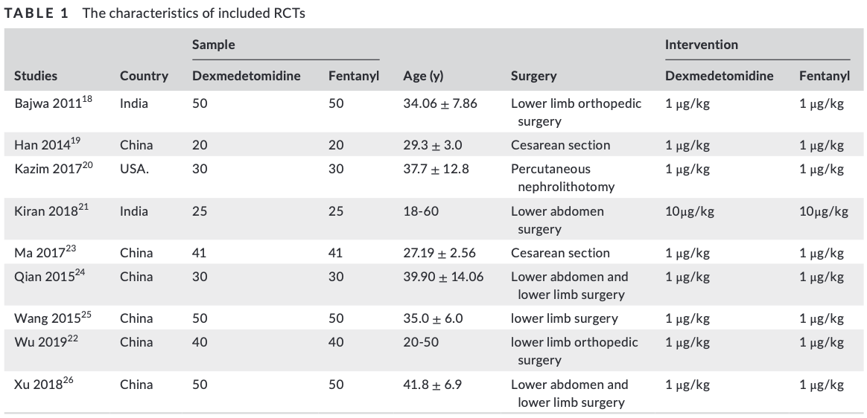
Zhang et al.³
- Faster onset by 1.13min
- Higher levels of sedation
- Their analysis did not find any significant risk of side effects (bradycardia, dizziness, pruritus, dry mouth, shivering, nausea, and vomiting), with the exception that more patients in the treatment group experienced hypotension than in the control group.
- Symptoms indicative of hypotension and bradycardia events were more common in the dexmedetomidine group, but the difference in the overall risk of hypotension and bradycardia was statistically insignificant
Yang et al.⁴
- Epidural dexmedetomidine reduces intra‑operative and post‑operative visceral pain and produces better sedation during surgery and following delivery, without any significant influence on morphine‑associated side effects and post‑operative analgesia, in females undergoing elective cesarean section under epidural anesthesia with morphine and ropivacaine

References
- Riham Hasanein & Sahar Elshal (2016) Extending labor epidural analgesia using lidocaine plus either dexmedetomidine or epinephrine for emergency cesarean section, Egyptian Journal of Anaesthesia, 32:3, 351-356,DOI: 10.1016/j.egja.2016.05.006
- Qian M, Gao F, Liu J, Xu P. Dexmedetomidine versus fentanyl as adjuvants to ropivacaine for epidural anaesthesia: A systematic review and meta-analysis. Int J Clin Pract. 2021 May;75(5):e13772. doi: 10.1111/ijcp.13772. Epub 2020 Dec 20. PMID: 33078536.
- Zhang, X., Wang, D., Shi, M. et al. Efficacy and Safety of Dexmedetomidine as an Adjuvant in Epidural Analgesia and Anesthesia: A Systematic Review and Meta-analysis of Randomized Controlled Trials. Clin Drug Investig 37, 343–354 (2017). https://doi.org/10.1007/s40261-016-0477-9
- Yang Y, Song C, Song C, Li C. Addition of dexmedetomidine to epidural morphine to improve anesthesia and analgesia for cesarean section. Exp Ther Med. 2020 Mar;19(3):1747-1754. doi: 10.3892/etm.2020.8429. Epub 2020 Jan 7. PMID: 32104229; PMCID: PMC7027145.

Continuous Labor Epidurals and Dexmedetomidine
Proposed Mixture: Ropivacaine 0.1% with Dexmedetomidine 0.3-0.5 mcg/ml

Faster onset, denser block, longer duration, fewer PCEA boluses, less pruritus, less nausea, no statistical difference of bradycardia and hypotension

Brief Literature Summary
Wei et al.¹
- Continuous epidural labor analgesia with ropivacaine + dexmedetomidine (Group D) (n=48) vs ropivacaine with sufentanil (n=58) (Group S)
- No difference in umbilical arterial blood gas findings (pH, lactic acid), Apgar scores, and NBNA (Neonatal Behavioral Neurological Assessment) scores. No significant difference between the VAS and maternal or fetal heart rate between the two groups
- The duration of the first epidural infusions in Group D (median 115 min, 90–130) was greater than in Group S
- Fewer PCEA boluses and less local anesthetic volume in Group D
- The incidence of pruritus, fever, nausea, and vomiting in Group D was significantly lower in the DEX group
Pang et al.²
- Epidural dexmedetomidine at three different doses: 0.3, 0.4, or 0.5 μg/ml, compared to fentanyl at the traditional clinical concentration of 2 μg/ml, as adjuvants to epidural 0.125% ropivacaine. 188 patients were involved in a randomized, double-blinded study
- PIEB 8mL Q40min PCEA 8mL Q15min Max 30mL
- The study found that the amount of epidural ropivacaine used was lower in the dexmedetomidine groups compared to the fentanyl group.
- The frequency of PCEA boluses was significantly higher in the fentanyl group.
- The fentanyl group experienced a 17.5% incidence of itching (pruritus), while none was reported in the dexmedetomidine groups.
- The study data showed no adverse effects of dexmedetomidine on maternal or neonatal outcomes.
- Optimal dose may be 0.3mcg/mL. Further increases in the dose of dexmedetomidine might only have resulted in non-therapeutic effects and even potentially increased risk of side effects such as a higher degree of motor block, as experienced in the 0.5 μg/ml dexmedetomidine group in the present study. Further study to determine the full dose-response of epidural ropivacaine with dexmedetomidine is warranted.

References:
- Wei Gao, Jie Wang, Zhiguo Zhang, Haiying He, Huiwen Li, Ruili Hou, Liping Zhao, Daniel Muthee Gaichu, "Opioid-Free Labor Analgesia: Dexmedetomidine as an Adjuvant Combined with Ropivacaine", Journal of Healthcare Engineering, vol. 2022, Article ID 2235025, 7 pages, 2022. https://doi.org/10.1155/2022/2235025
- Pang, R.-Y., Shen, Y.-H., Jin, X.-Q., Xu, H.-F., Wang, Y., Zhu, B.-X., Lin, S.-F., & Xiao, F. (2022). Comparison of epidural dexmedetomidine to fentanyl in reducing ropivacaine dose in Programmed Intermittent Epidural Bolus plus Patient Controlled Epidural Analgesia during labor: A randomized, double-blind, controlled study. Frontiers in Medicine, 9. doi:10.3389/fmed.2022.935643
- Zhou H, Wen J, Guo G, Zhao Y, Liu W. Evaluation of the effect of dexmedetomidine combined with ropivacaine in epidural labor analgesia: a systematic review and meta-analysis. Minerva Anestesiol. 2022 Oct;88(10):842-852. doi: 10.23736/S0375-9393.22.16284-X. Epub 2022 Mar 22. PMID: 35315623.

Peripheral Nerve Blocks and Dexmedetomidine
Adding dexmedetomidine to local anesthetics like bupivacaine and ropivacaine provides superior analgesia in various nerve blocks compared to local anesthetics alone. Dexmedetomidine shortens the onset time and prolongs the duration of sensory and motor nerve blocks across femoral, interscalene brachial plexus, and other brachial plexus blocks. The optimal dose of perineural dexmedetomidine appears to be around 2 μg/kg or 2 mg/kg, as higher doses further extend analgesia duration without significantly increasing adverse effects. However, the risk of transient hypotension may be greater with higher dexmedetomidine doses. Overall, dexmedetomidine as an adjuvant allows clinicians to achieve prolonged analgesia from single-shot nerve blocks and improve postoperative pain control.

Proposed Mixture
Outpatient: 0.5-1 mcg/kg along with local anesthetic
Inpatient: 1-2 mcg/kg along with local anesthetic
Contraindications: hypotension, bradycardia, severe pulmonary hypertension, OSA, acute/chronic respiratory failure, morbid obesity, any shock state, high frailty
Other considerations: Pre vs postop block, PACU time, early PT, discharge, and level of sedation

Brief Literature Summary
Dai et al.¹
- Meta-analysis of 12 studies on dexmedetomidine as an adjuvant to ropivacaine for brachial plexus blocks.
- Dexmedetomidine reduced onset times and prolonged duration of sensory/motor block and analgesia compared to ropivacaine alone. Prolonging the block on average by 228 min
- No difference in bradycardia or hypotension between groups.
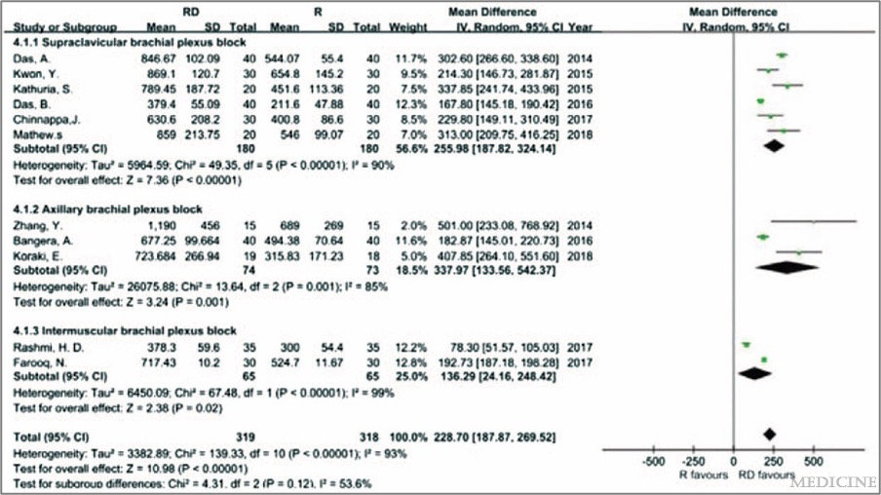
Jung et al.²
- Randomized controlled trial comparing three doses of dexmedetomidine (1, 1.5, 2 mg/kg) as an adjuvant to ropivacaine for interscalene brachial plexus block in patients undergoing shoulder arthroscopy.
- Dexmedetomidine 2 mg/kg provided the longest duration of analgesia (~20 hours) compared to lower doses and control. Transient hypotension is more common with 1.5 and 2 mg/kg doses.
- Concludes 2 mg/kg optimal dose to prolong analgesia after shoulder arthroscopy but associated with increased hypotension risk.
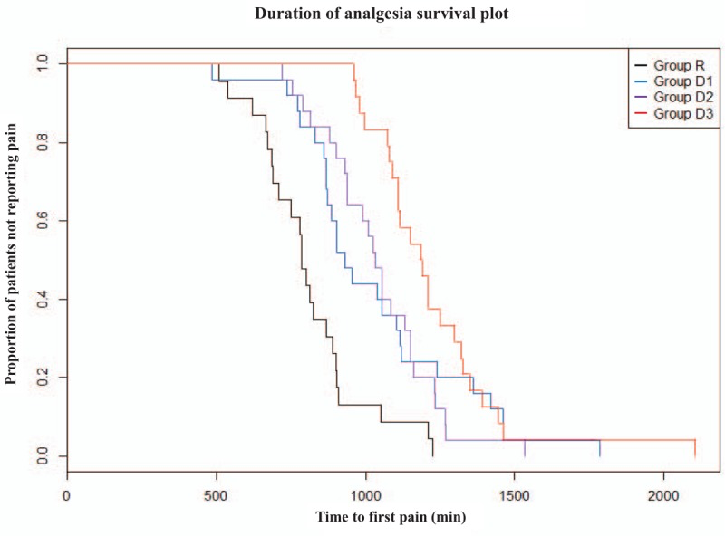
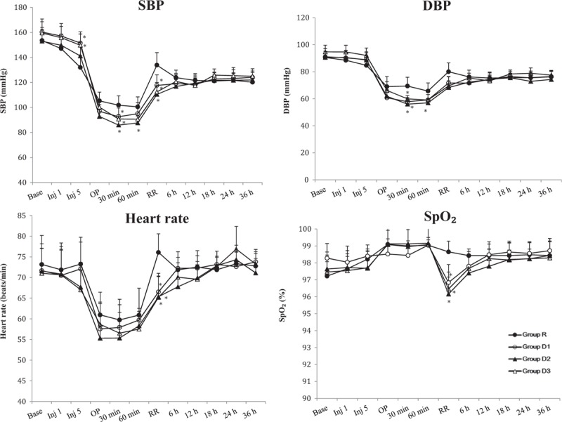
Packiasabapathy et al.³
- Randomized controlled trial comparing two doses of dexmedetomidine (1 μg/kg and 2 μg/kg) as an adjuvant to bupivacaine for femoral nerve block in patients undergoing total knee arthroplasty.
- Dexmedetomidine 2 μg/kg provided longer duration of analgesia and reduced postoperative morphine consumption compared to 1 μg/kg dose and control. No significant difference in adverse effects between groups.
- Concludes 2 μg/kg dexmedetomidine superior to 1 μg/kg for prolonging analgesia after total knee arthroplasty.

References
- Dai, Wei MMa; Tang, Maocai MMb; He, Kaihua PhDa,∗. The effect and safety of dexmedetomidine added to ropivacaine in brachial plexus block: A meta-analysis of randomized controlled trials. Medicine 97(41):p e12573, October 2018. | DOI: 10.1097/MD.0000000000012573
- Jung HS, Seo KH, Kang JH, Jeong JY, Kim YS, Han NR. Optimal dose of perineural dexmedetomidine for interscalene brachial plexus block to control postoperative pain in patients undergoing arthroscopic shoulder surgery: A prospective, double-blind, randomized controlled study. Medicine (Baltimore). 2018 Apr;97(16):e0440. doi: 10.1097/MD.0000000000010440. PMID: 29668608; PMCID: PMC5916649.
- Packiasabapathy SK, Kashyap L, Arora MK, Batra RK, Mohan VK, Prasad G, Yadav CS. Effect of dexmedetomidine as an adjuvant to bupivacaine in femoral nerve block for perioperative analgesia in patients undergoing total knee replacement arthroplasty: A dose-response study. Saudi J Anaesth. 2017 Jul-Sep;11(3):293-298. doi: 10.4103/sja.SJA_624_16. PMID: 28757829; PMCID: PMC5516491.
- Chen Z, Liu Z, Feng C, Jin Y, Zhao X. Dexmedetomidine as an Adjuvant in Peripheral Nerve Block. Drug Des Devel Ther. 2023 May 17;17:1463-1484. doi: 10.2147/DDDT.S405294. PMID: 37220544; PMCID: PMC10200118.

Nebulized dexmedetomidine for PDPH
Proposed Mixture: Dose 1 mcg/kg diluted to 4 ml with saline, can be administered q12h

- 65% intranasal route bioavailability
- Minimal hemodynamic effects, sedation
- A good addition to non-invasive or conservative management of PDPH^{1,3}
- Potential mechanisms:
  - Reduced cerebral blood flow (CBF)²
    - DEX decreases CBF in humans and animals secondary to cerebrovascular vasoconstriction
    - venous vasoconstrictive effects of DEX
  - Decreased CSF absorption
    - CSF is mainly drained by the brain surface vessels and not by the subarachnoid villi
    - DEX may act to increase the CSF pressure by decreasing CSF absorption by cerebral vessels on the brain surface

References
- Kumar A, Kumar A, Sinha C, Anant M, Singh JK. Dexmedetomidine nebulization: an answer to post-dural puncture headache? Int J Obstet Anesth. 2019 Nov;40:155-156. doi: 10.1016/j.ijoa.2019.06.004. Epub 2019 Jun 19. PMID: 31345663.
- Tsaousi GG, Bilotta F. Is dexmedetomidine a favorable agent for cerebral hemodynamics? Indian J Crit Care Med. 2016 Jan;20(1):1-2. doi: 10.4103/0972-5229.173675. PMID: 26955209; PMCID: PMC4759987.
- Mowafy SMS, Ellatif SEA. Effectiveness of nebulized dexmedetomidine for treatment of post-dural puncture headache in parturients undergoing elective cesarean section under spinal anesthesia: a randomized controlled study. J Anesth. 2021 Aug;35(4):515-524. doi: 10.1007/s00540-021-02944-6. Epub 2021 May 16. PMID: 33993346.

