References
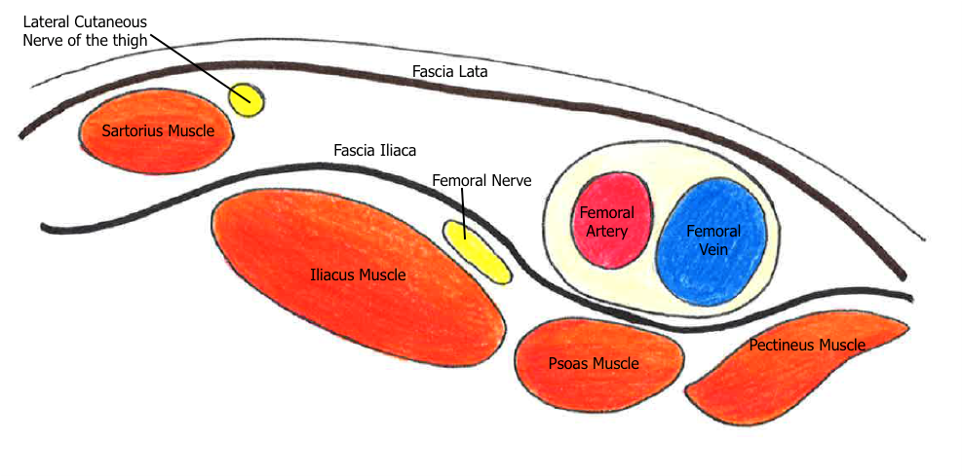
nysora
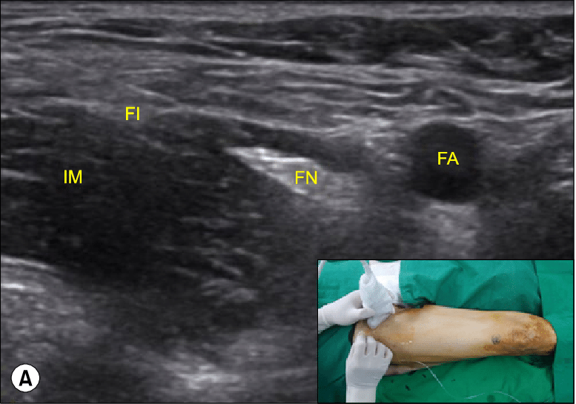
https://www.researchgate.net/figure/Femoral-nerve-block-A-Fascia-iliaca-compartment-block-B-FA-femoral-artery-FN_fig1_288827648
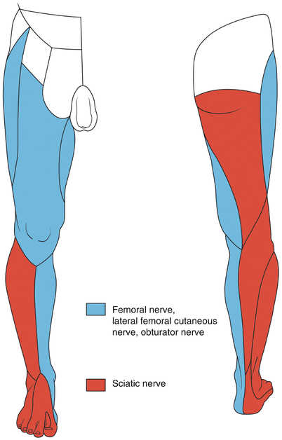
https://link.springer.com/chapter/10.1007/978-3-319-05131-4_59

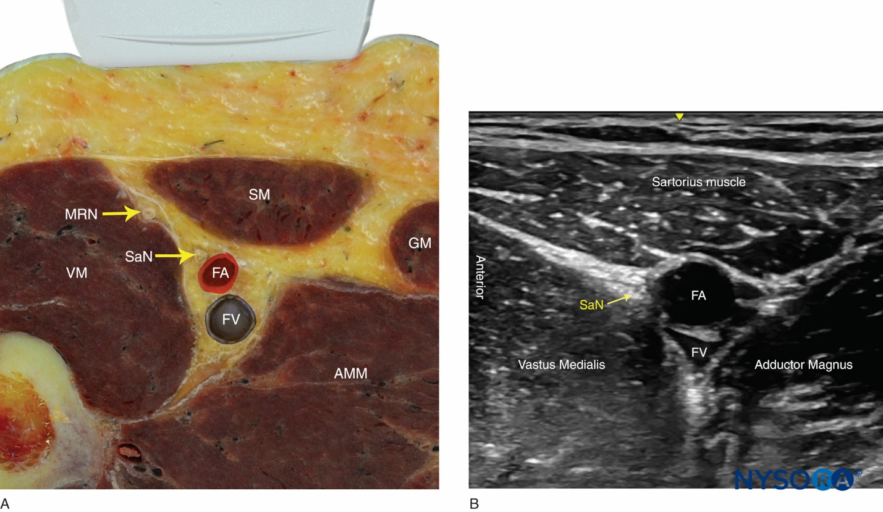
https://www.nysora.com/regional-anesthesia-for-specific-surgical-procedures/lower-extremity-regional-anesthesia-for-specific-surgical-procedures/foot-and-anckle/ultrasound-guided-saphenous-subsartorius-adductor-canal-nerve-block/

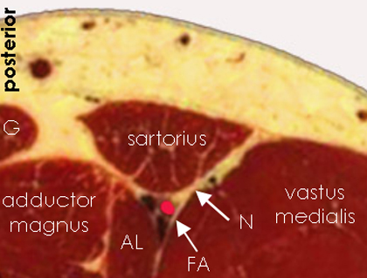
http://www.usra.ca/regional-anesthesia/specific-blocks/lower-limb/saphenousnerve.php

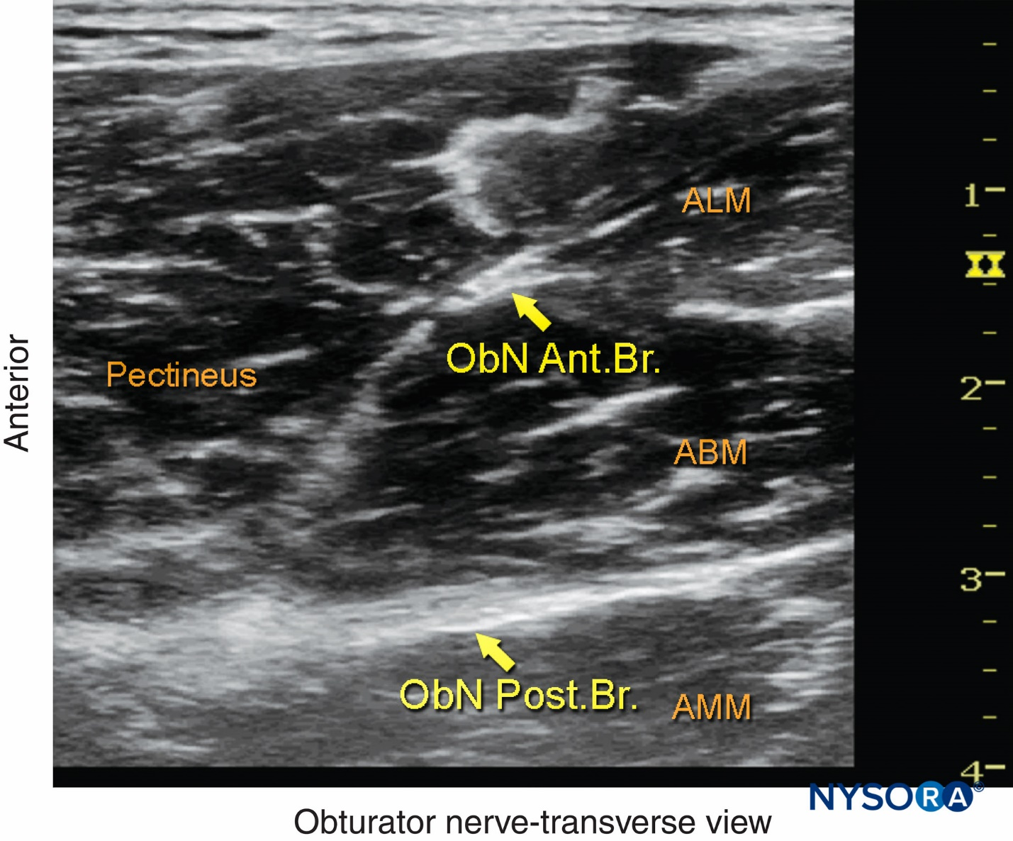
https://www.nysora.com/techniques/lower-extremity/obturator/ultrasound-guided-obturator-nerve-block/

