Websites/Social Media People:

- Rishi Kumar
  - https://www.instagram.com/rishimd/?hl=en
Rishi Kumar, MD, FACC | RK.md's (@rishimd) profile on Instagram • 656 posts
139k Followers, 21 Following, 656 Posts - See Instagram photos and videos from Rishi Kumar, MD, FACC | RK.md (@rishimd)
www.instagram.com

  - https://rk.md/
RK.md | Medicine, Education, Technology, Life
Musings of Rishi Kumar, MD: a tech-savvy, board-certified cardiothoracic anesthesiologist and intensive care physician with a passion for education
rk.md
  - 

- David Convissar
  - https://www.instagram.com/countbackwardsfrom10/?hl=en
David Convissar, MD (@countbackwardsfrom10) is on Instagram
32.9k Followers, 64 Following, 237 Posts - See Instagram photos and videos from David Convissar, MD (@countbackwardsfrom10)
www.instagram.com

  - https://www.countbackwardsfrom10.com/
C B F 10
Toss out the power point slides and check out our digital chalk talks. If there’s a topic out there, we can teach it in 10 minutes or less. Watch now.
www.countbackwardsfrom10.com
  - 

- Eddy Joe
  - https://www.instagram.com/eddyjoemd/?hl=en
Eddy J. Gutierrez, MD (@eddyjoemd) on Instagram • 586 photos and videos
68k Followers, 298 Following, 586 Posts - See Instagram photos and videos from Eddy J. Gutierrez, MD (@eddyjoemd)
www.instagram.com

  - https://eddyjoemd.com/
@eddyjoemd: an intensivist on a learning frenzy | Caring for the critically ill using evidence-based medicine.
Now that tocilizumab is so difficult to obtain (written on 9/2/21 and obviously subject to change), we need another therapy to help improve outcomes in patients with COVID-19 who are hospitalized and critically ill.
eddyjoemd.com

- Ali Haider
  - https://www.instagram.com/yourheartdoc/?hl=en
Ali Haider MD, FACC (@yourheartdoc) on Instagram • 619 photos and videos
132k Followers, 760 Following, 619 Posts - See Instagram photos and videos from Ali Haider MD, FACC (@yourheartdoc)
www.instagram.com

Primary Literature:

- https://academic.oup.com/bja/article/115/6/940/241699
Social media and anaesthesia journals | BJA: British Journal of Anaesthesia | Oxford Academic
An active Twitter account with a high Klout score directly-correlated with higher journal impact factor (P=0.034) and with a greater number of article citations (P=0.016) than journals not embracing social media.A highly-performing Twitter account was also associated with an increase in impact factor in the period after Twitter adoption (P=0.01), while journals without a social media presence ...
academic.oup.com

- https://rapm.bmj.com/content/45/3/239
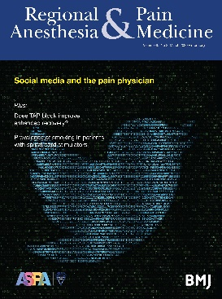 | Social media for the regional anesthesiologist: can we use it in place of medical journals? | Regional Anesthesia & Pain Medicine - Regional Anesthesia & Pain Medicine | A BMJ anesthesiology journal  The regional anesthesia community regularly uses social media for advocacy and education. Well-known leaders in the field are willing to share their opinions with colleagues in a public forum. Some visionaries predict that the influence of social media will soon transcend that of the traditional academic journal. While physicians support the use of social media, an trend may exist toward ...  rapm.bmj.com
- https://academic.oup.com/bja/article/115/6/940/241699
Social media and anaesthesia journals | BJA: British Journal of Anaesthesia | Oxford Academic
An active Twitter account with a high Klout score directly-correlated with higher journal impact factor (P=0.034) and with a greater number of article citations (P=0.016) than journals not embracing social media.A highly-performing Twitter account was also associated with an increase in impact factor in the period after Twitter adoption (P=0.01), while journals without a social media presence ...
academic.oup.com
- https://www.ncbi.nlm.nih.gov/pmc/articles/PMC6688444/
Use of Smart Phones and Social Media in Medical Education: Trends, Advantages, Challenges and Barriers
The technological advancements have transformed the society into a global forum influencing the educational processes and learning environments. Medical education is no exemption with an increasing trend to use the social media and smart phones for teaching ...
www.ncbi.nlm.nih.gov

- https://www.ncbi.nlm.nih.gov/pmc/articles/PMC4435861/
Advancing social media in medical education
www.ncbi.nlm.nih.gov

Podcasts:
- Accrac - Johns Hopkins
  - http://accrac.com/
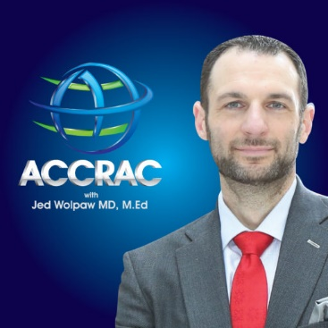 | ACCRAC Podcast – Anesthesia and Critical Care Reviews and Commentary  In this 203rd episode I welcome Dr. Tammy Euliano to the show to discuss how she got involved in writing fiction, how she took her idea all the way to a published novel called Fatal Intent, and how anesthesiologists are portrayed in popular fiction.  accrac.com
  - 

- Depth of Anesthesia - MGH
  - https://depthofanesthesia.com/
Depth of Anesthesia – A Podcast Critically Exploring Clinical Practices
Depth of Anesthesia is a podcast that critically explores dogmatic practices (we call them claims). Join us as we think deeper about why we do what we do.
depthofanesthesia.com

