References:
https://www.nysora.com/regional-anesthesia-for-specific-surgical-procedures/abdomen/ultrasound-guided-transversus-abdominis-plane-quadratus-lumborum-blocks/
https://www.ncbi.nlm.nih.gov/books/NBK547730/
https://www.ncbi.nlm.nih.gov/pmc/articles/PMC4294000/
https://www.wfsahq.org/components/com_virtual_library/media/af1feee1842cacd2a2713b997013c22f-7ba7b6b528c36495806bfc3928f8ab53-Ultrasound-Guided-Rectus-Sheath-Block--Update-26-2010-.pdf
Gray, A. T., & Gray, A. T. (2019). Atlas of ultrasound-guided regional anesthesia. Third edition. Philadelphia, PA: Elsevier, Inc.
https://nysoralms.com/courses/erector-spinae-plane-block/lessons/anatomy-20/
https://www.asra.com/asra-news/article/39/how-i-do-it-erector-spinae-block-for-rib
Images:
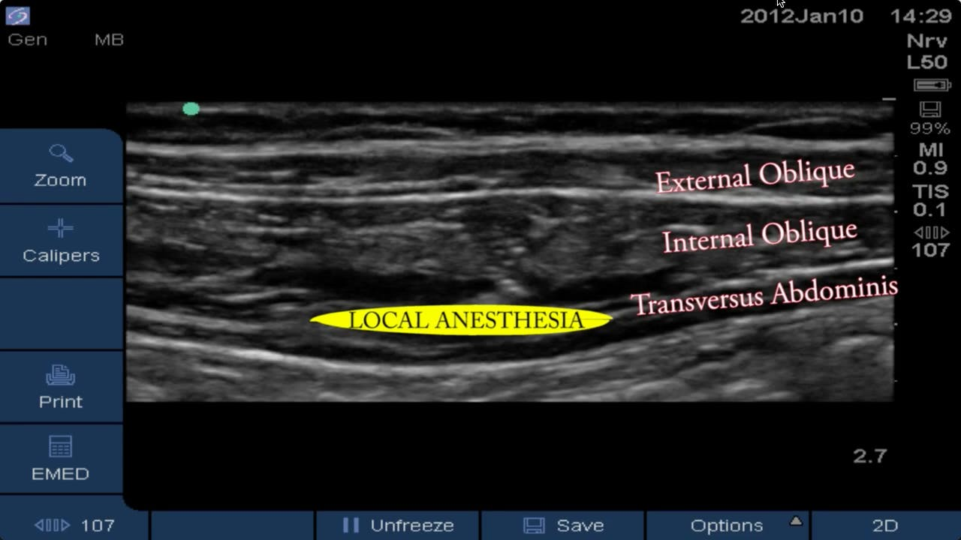
TAP block: Shows three layers of the abdomen and where the local anesthetic is deposited
https://www.blockjocks.com/tap-quadratus-lumborum-rectus-sheath/videos/1-14-12-ultrasound-guided-tap-block

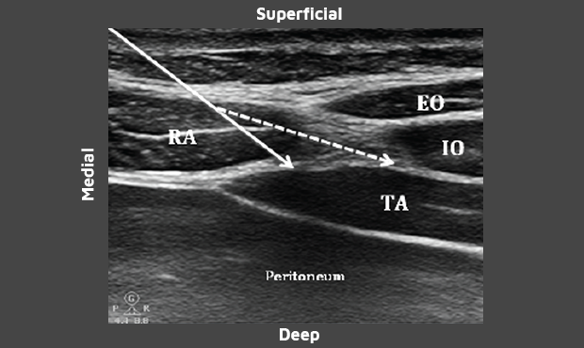
Rectus Sheath transition to the three main abdominal muscles where you perform a TAP
https://www.exparel.com/hcp/tap

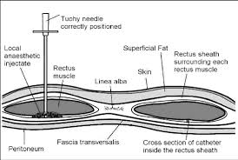
Rectus Sheath Anatomy
https://www.wfsahq.org/components/com_virtual_library/media/af1feee1842cacd2a2713b997013c22f-7ba7b6b528c36495806bfc3928f8ab53-Ultrasound-Guided-Rectus-Sheath-Block--Update-26-2010-.pdf
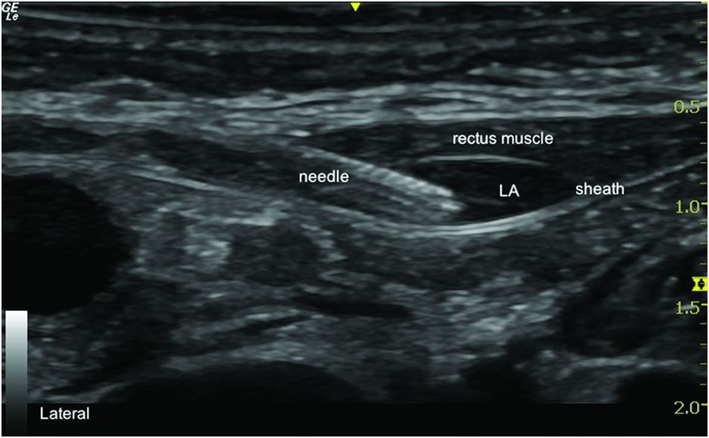
Rectus Sheath Block showing were the needle is placed to deposit the local anesthetic
https://aneskey.com/ultrasound-guided-rectus-sheath-block/

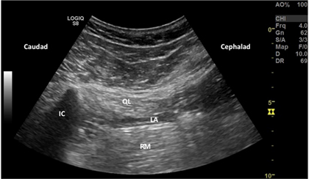
Local anesthetic injected between the QL and Psoas muscles
http://www.usra.ca/regional-anesthesia/specific-blocks/trunk/tqlblock.php
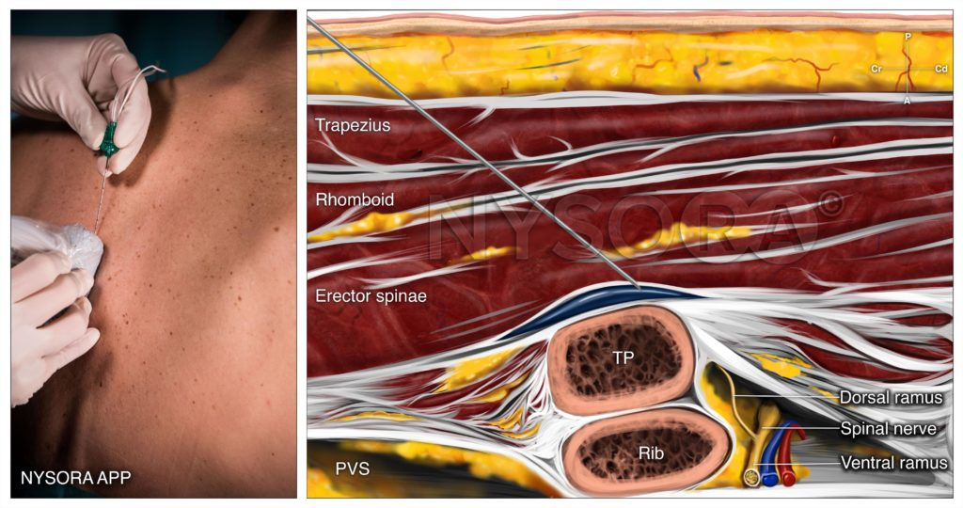
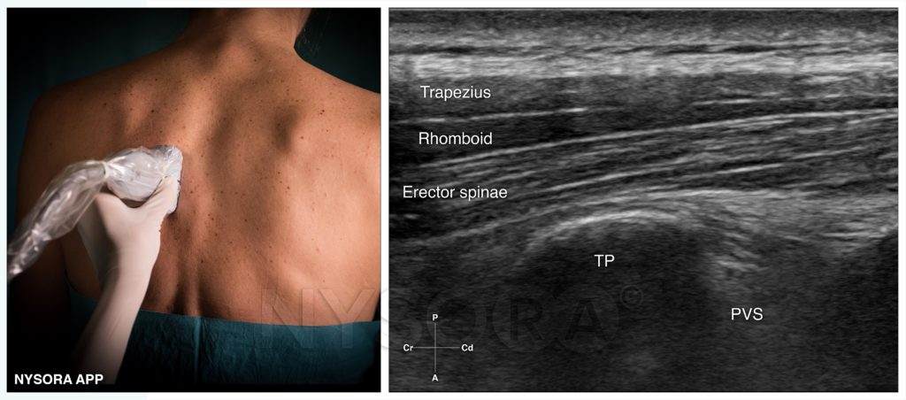
https://nysoralms.com/courses/erector-spinae-plane-block/lessons/technique-17/

