Sciatic References
References
NYSORA regional block of the ankle: https://www.nysora.com/regional-anesthesia-for-specific-surgical-procedures/lower-extremity-regional-anesthesia-for-specific-surgical-procedures/foot-and-anckle/ankle-block/

Hall, B. A., & Chantigian, R. C. (2014). Anesthesia: A Comprehensive Review E-Book. Elsevier Health Sciences.

Open Anesthesia: https://www.openanesthesia.org/ankle_block_anatomy/

McLeod DH, Wong DH, Vaghadia H, Claridge RJ, Merrick PM. Lateral popliteal sciatic nerve block compared with ankle block for analgesia following foot surgery. Canadian journal of anaesthesia. 1995 Sep 1;42(9):765.

Myerson MS, Ruland CM, Allon SM. Regional anesthesia for foot and ankle surgery. Foot & ankle. 1992 Jun;13(5):282-8.
Gray, A. T. (2019). Atlas of ultrasound-guided regional anesthesia. Philadelphia, PA: Elsevier, Inc.
Hadzic, A. (2019). Hadzic’s Peripheral Nerve Blocks And Anatomy For Ultrasound-Guided Regional Anesthesia. S.l.: MCGRAW-HILL EDUCATION.
Barash, P. G. (2017). Clinical Anesthesia. Philadelphia: Wolters Kluwer/Lippincott Williams & Wilkins.
PICTURES
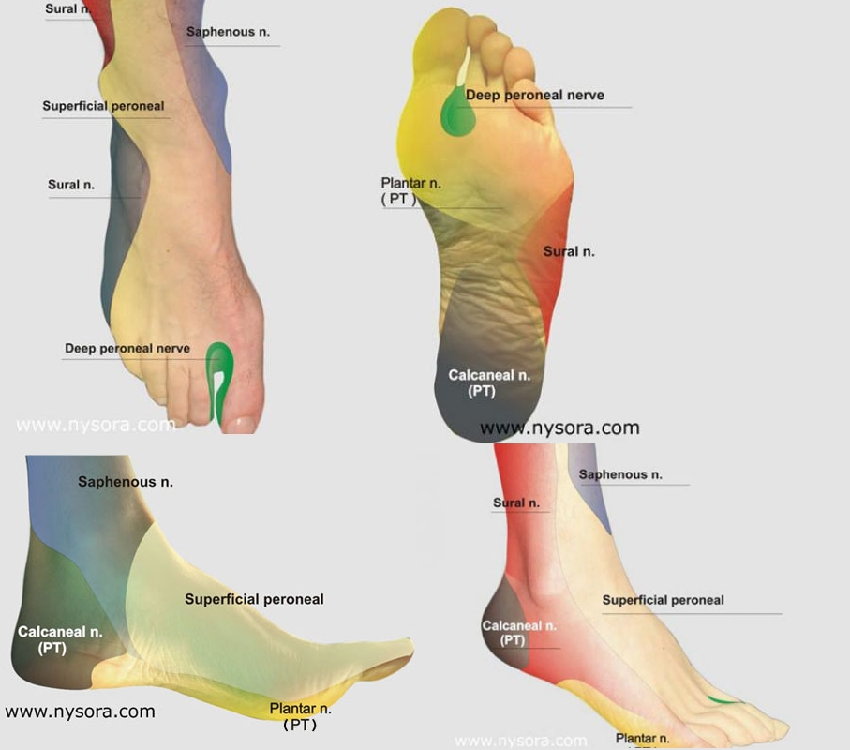
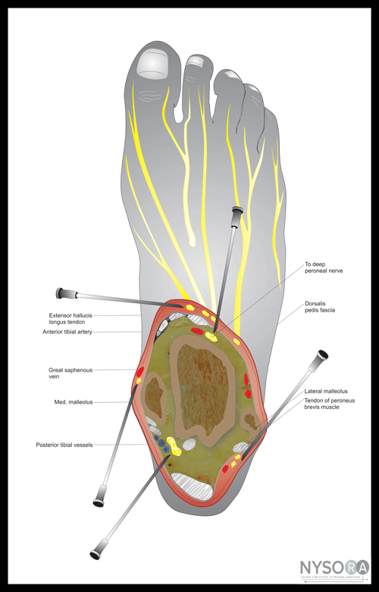
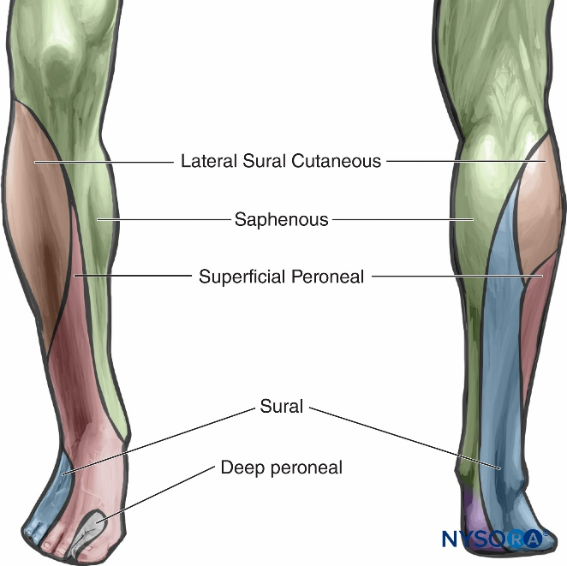
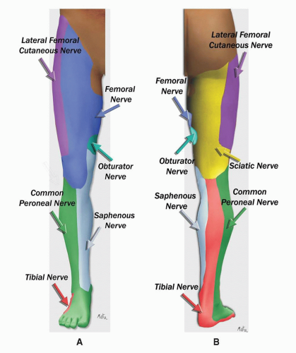https://aneskey.com/wp-content/uploads/2016/06/C2-FF1-2.gif

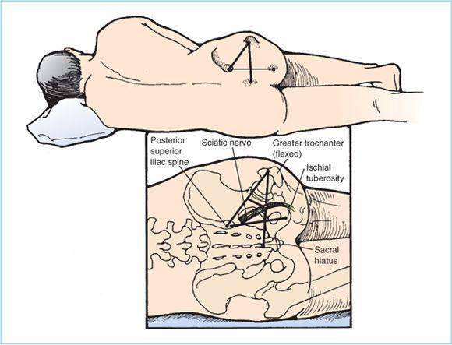
ansekey.com
